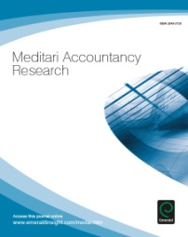
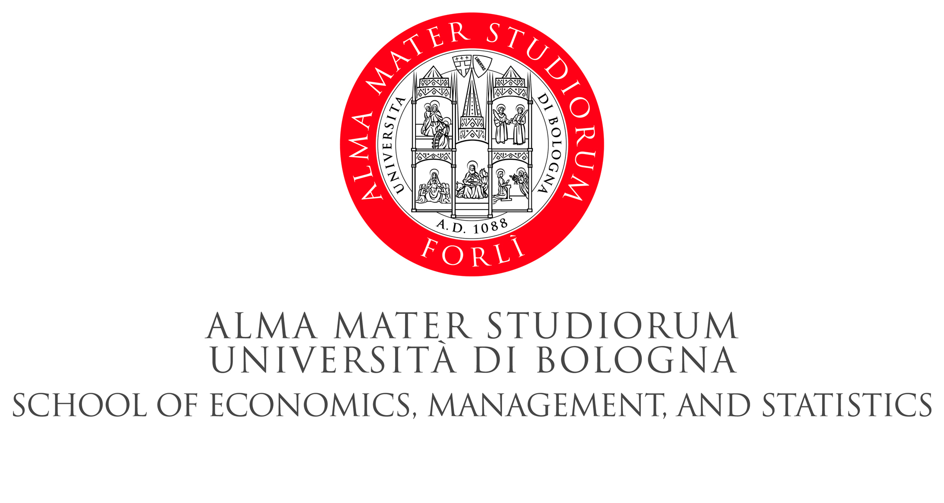

Announcing the:

SIDREA International Workshop (SIW)
Meditari Accountancy Research European Conference
and Doctoral Colloquium 2015

2-3 July 2015

Current Issues in Social, Environmental and Gender Accounting
Papers on other topics of accounting and related interdisciplinary research will be welcome.

at
University of Bologna, Italy
School of Economics, Management and Statistics – Forlì Campus
Piazzale della Vittoria, 15 – 47121 Forlì (FC), Italy
The conference provides direct pathways towards publication in the research journal Meditari Accountancy Research.

The University of Bologna - School of Economics, Management and Statistics – Forlì Campus and the Meditari Accountancy Research Journal with the support of the Società Italiana dei Docenti di Ragioneria e di Economia Aziendale (SIDREA) are pleased to announce their joint event on the theme “Current Issues in Social, Environmental and Gender Accounting”. The main objective of the SIW - Meditari Conference and Doctoral Colloquium is to advise, provide guidance, and debate on research projects carried out by accounting and business economics researchers working at all levels of academic positions. Participants of the SIW - Meditari Conference will have the opportunity to interact with foreign and Italian faculty members.
The University of Bologna is considered to be the oldest university in the Western world. Today, it is a leader in European higher education and famous for its beautiful campus, which is integrated with the city. The University of Bologna has adopted a multi-campus structure, which creates a unique environment for education and research, creating a special university and community life. http://www.unibo.it/en/university

Conference Objectives
The main objectives of the SIW - Meditari Conference are to advise, guide and debate accounting and related interdisciplinary research, leading to the publication of quality research papers in Meditari Accountancy Research. It is expected that the SIW - Meditari Conference and Doctoral Colloquium will provide a platform for discussion for research proposals, working papers, methods and methodological issues.

Review Process and Publication Plan
The papers submitted will follow a double blind peer review process and those selected will be invited for presentation during the parallel sessions. The SIW - Meditari Conference and Doctoral Colloquium will feature several national and international academics, including Professor Jane Broadbent, Professor Charl de Villiers, Professor James Guthrie and Professor Carol Tilt.
A selection of best papers presented during the SIW - Meditari Conference is expected to be published in a special issue of Meditari Accountancy Research. The theme of the special issue will be current issues in social, environmental and gender accounting, and will be edited by Professor Charl de Villiers, Professor. Federica Farneti and Professor Benedetta Siboni.
The other papers presented at the SIW - Meditari Conference will be subject to, and may progress towards, publication in the journal’s normal refereeing process.

Key Plenary Speakers
Professor Jane Broadbent, Royal Holloway, University of London, UK
Professor Carol Tilt, Australian Institute of Business, Australia.

Meditari Accountancy Research
Meditari Accountancy Research takes its name from the Latin for constantly pondering, suggesting a journey towards a better understanding of accountancy related matters through research. The journal is a double blind refereed publication.
Meditari Accountancy Research aims to publish research in the main subject areas included in accountancy, as well as research examining other questions of interest to the greater accounting community, including interdisciplinary approaches. The journal is on the Australian ERA journals list, ranked by the Australian Business Deans Council (ABDC), and on the South African DHET accredited journals list. The journal is indexed and extracted by: ABI/INFORM Complete/ ABI/INFORM Global (ProQuest),Academic Search Alumni Edition/ Academic Search Complete/ Academic Search Elite/ Academic Search Premier (EBSCO) Accounting & Tax Periodicals (ProQuest), Business Source Alumni Edition, Business Source Complete/Business Source Corporate Plus/ Business Source Elite/ Business Source Premier (EBSCO), Cabell's Directory of Publishing Opportunities in Accounting, Professional ABI/INFORM Complete/ Professional ProQuest Central/ ProQuest Central (ProQuest).
Further information about the journal is available at:
http://www.emeraldgrouppublishing.com/products/journals/journals.htm?id=MEDAR

Doctoral Colloquium
The purpose is to bring researchers together to offer plenary sessions by leading researchers, dedicated workshops presented by subject area specialists, offering the opportunity to present their work, receive expert comment and advice from established faculty members, and provide an opportunity for group networking. The Doctoral Colloquium will be led by Professor Jill Atkins (University of Reading), Professor Andrew Stark (Manchester Business School), Professor Carol Tilt (University of South Australia), Professor John Dumay (Macquarie University) and Professor Sumit Lodhia (South Australia University). The Meditari Accountancy Research Doctoral Colloquium will take place on Thursday 2 July 2015. Full paper or extended abstract will be welcome for the Doctoral Colloquium. Further paper submission guidelines are provided below.

Paper submission guidelines
The paper must be submitted by Monday 25 May 2015, both for the Conference and the Doctoral Colloquium.
Please consider the following when submitting your paper.
An International Scientific Committee will review all submissions, and accepted authors will be asked to submit a final revised full paper.
- Papers should preferably not exceed 9,000 words, including an extended abstract, figures, references and appendices.
- The extended abstract, of about 1,000 words in length, must contain:
    - purpose (mandatory);
    - design/methodology/approach (mandatory);
    - findings (mandatory);
    - research limitations/implications (if applicable);
    - practical implications (if applicable);
    - social implications (if applicable);
    - originality/value (mandatory);
    - keywords (mandatory and no more than ten).
- Papers must not have previously been published.

Registration
The SIW - Meditari Conference and the Doctoral Colloquium attendance is free of charge. However, due to limited capacity, registration is required, via e-mail to daniela.sangiorgi5@unibo.it no later than 30 May 2015.
Details of the program will be available on the web site of the School of Economics, Business and Statistics – Forlì Campus, and signposted on the Meditari Accountancy Research website.

Scientific Committee*
- Charl de Villiers - AUT University, Auckland, New Zealand
- John Dumay Macquarie University (Australia)
- Federica Farneti University of Bologna (Italy)
- James Guthrie Macquarie University (Australia) and University of Bologna (Italy)
- James Hazelton - Macquarie University (Australia)
- Sumit K. Lodhia - University of South Australia (Australia)
- Federica Ricceri - Padova University (Italy)
- Grant Samkin - The University of Waikato (New Zealand)
- Daniela Sangiorgi - University of Bologna (Italy)
- Benedetta Siboni - University of Bologna (Italy)
- Andrew Stark - University of Manchester (UK)

Organising Committee*
- Federica Farneti, University of Bologna (Italy)
- James Guthrie, Macquarie University (Australia) and University of Bologna (Italy)
- Daniela Sangiorgi, University of Bologna (Italy)
- Benedetta Siboni, University of Bologna (Italy)

*All Editorial Board Members of Meditari Accountancy Research

Please direct any questions to meditari2015@unibo.it
Location
Forlì - University of Bologna, Italy, School of Economics, Management and Statistics, Forlì Campus.
Piazzale della Vittoria, 15 – 47121 Forlì (FC), Italy.
https://www.google.it/maps/preview?q=piazzale+vittoria+15+forl%C3%AC+map&ie=UTF-8&hq=&hnear=0x132b57f367cb8ac5:0x6b781057c73f1f79,Piazzale+della+Vittoria,+15,+47100+Forl%C3%AC+FC&gl=it&ei=WeLEU-joLOSv7AbsyYHYBA&ved=0CB8Q8gEwAA

Travel Information
By Airplane - The airport closest to the School is Bologna’s Marconi Airport, about 70 km from Forlì. There is a shuttle from the airport to Bologna train station every 30 minutes. Marco Polo Airport in Venezia is about 200 km away from Forlì ( accessible by train), and Milano Linate and Milano Malpensa airports are about 300/350 km from Forlì.
By Train - The School is located about 800 metres from Forlì train station, which is served by an efficient intercity service from major Italian cities.
By Car - Forlì is one of the motorway exits of the highway A14. It is about 65 Km from Bologna, 130 km from Ancona and 82 km from the connection with the A1 Milano
- Napoli. For those coming from the SS E45, the motorway exit for Forlì is 8 km away.

Suggested Accommodation
Close to the Conference Venue
Hotel Michelangelo
http://www.hotelmichelangelo.fc.it
Hotel Gardenia
http://www.gardeniahotel.eu
Close to the City Centre
Hotel Executive
http://www.executiveforli.it/default.aspx
Hotel Masini
http://www.masinihotel.it
Hotel Marta
http://www.hotelmartaforli.it
Foresteria Universitaria Docenti (B&B only for Academics)
http://www.ceub.it/default.asp?id=403#.U8TjT7SKCM8
Close to the Highway
BEST WESTERN Hotel Globus City
http://www.hotelglobuscity.com
Hotel San Giorgio
http://www.hotelsangiorgioforli.it

Key Dates
25 May 2015 | Deadline for full paper submission - SIW - Meditari Conference – emailed to federica.farneti@unibo.it and meditari2015@unibo.it  Deadline for Full paper or extended abstract submission - Doctoral Colloquium – emailed to benedetta.siboni@unibo.it and meditari2015@unibo.it
15 June 2015 | Acceptance notification to authors (SIW - Meditari Conference and Doctoral Colloquium)
15 June 2015 | Registration deadline for SIW - Meditari Conference and Doctoral Colloquium – emailed to daniela.sangiorgi5@unibo.it and meditari2015@unibo.it
25 June 2015 | Deadline for revised full paper submission SIW - Meditari Conference – emailed to federica.farneti@unibo.it and meditari2015@unibo.it

